[one line]

PAPER TITLE – ALL CAPS; CENTERED; 14 PT TNR BOLD

Kent A. Harries, University of Pittsburgh, USA, kharries@pitt.edu
Author first name last name, affiliation, country, email
Each author on one centered line; 11 pt TNR
[two lines]

ABSTRACT
No more than 100 words; single spaced 11 pt Times New Roman (TNR). [the abstract will also appear separately in the proceedings and be universally searchable (google, etc.)]

KEYWORDS
Please provide at least three keywords separated by semicolons. Please do not use keywords like FRP, these will not really help promote your paper in a search in an FRP-focused conference.
[two lines]

INTRODUCTION (Heading 1: ALL CAPS; 11 pt TNR Bold))
All text shall be single spaced 11 pt TNR with one blank line separating paragraphs. Papers shall not exceed 12 pages in the format provided. Page numbers as indicated on this template shall be provided. Papers not adhering to this format will be rejected.

The official language of the conference is English.

Subheading (heading 2: 11 pt TNR Bold)
Sections of paper should not be numbered.

Second subheading (heading 3: 11 pt TNR italic)
Continue text

TABLES
Whenever possible, tables shall appear following the paragraphs in which they are first cited. Tables shall be centred in page and simply formatted using 11 pt TNR when possible (please use no smaller than 8 pt TNR in large tables). All cells shall have single line borders. All data reported as averages shall include necessary statistical information including sample size (n) and either standard deviation or coefficient of variation.

Table 1: Table captions should be centered above table
Group | n | fibre volume ratio |  | V_{f} = mx + b |  | V_{f} = be^{mx}
 |  | mean V_{f} | COV | mean m | COV | mean m | COV
M | 2450 | 0.235 | 0.130 | 0.025 | 0.32 | 0.105 | 0.315
P | 603 | 0.190 | 0.191 | 0.032 | 0.25 | 0.172 | 0.296
M+P | 3053 | 0.226 | 0.160 | 0.026 | 0.31 | 0.118 | 0.387

FIGURES
Whenever possible, figures shall appear following the paragraphs in which they are first cited. Figures shall be centred in page. Subfigures (a, b, c, etc.) shall be labelled below each subfigure (11 pt TNR preferred, but no smaller than 8 pt). If a table is used to align figure, please erase all table borders (example shown below in Figure 1). When appropriate, data should be presented with error bars and the meaning of the bars (i.e. +/- one SD) identified.

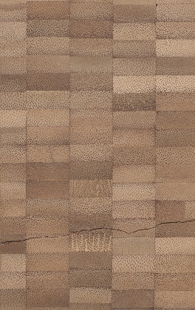 | 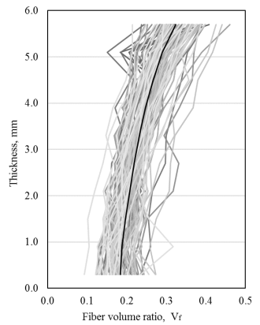 | 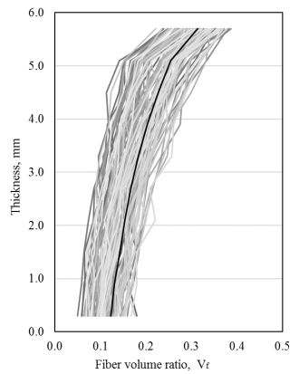
a) Group M glue-laminated beam cross section; each strip is 19 x 6 mm. | b) Group M | c) Group P
Figure 1: Figure captions should be centered below figure

EQUATIONS
Equations shall be numbered individually and provided in a separate line as shown below. Indent equations one tab stop. Simple equations may be typed in line and shall be italicised (Eq. 1); complex equations should use appropriate equation editor (Eq. 2). Please verify that equation fonts used are correctly represented when converted to PDF format.

E = mc² Eq. 1

$N_{cr}=\frac{P_{c}+P_{e}}{2c}-\sqrt{{\left(\frac{P_{c}+P_{e}}{2c}\right)}^{2}-\frac{P_{c}P_{e}}{c}}$ Eq. 2

CITATIONS
Citations shall follow APA style: https://pitt.libguides.com/citationhelp/apa7

ACKNOWLEDGEMENT
All papers shall include an acknowledgement of funding (if appropriate).

CONFLICT OF INTEREST
All papers shall include an author declaration of conflicts of interest; if there are no conflicts, please indicate this as follows:
The authors declare that they have no conflicts of interest associated with the work presented in this paper.

DATA AVAILABILITY
Each paper shall include one of the following data availability statements. Statement 3 is most commonly used:
- No data was assembled for the production of this paper.
- All necessary data is presented in this paper.
- Data on which this paper is based is available from the authors upon reasonable request.
- Data on which this paper is based is found in its entirety in [appropriate citation; usually a dissertation or thesis].
- Data on which this paper is based is proprietary [if this option is used, it is likely that a conflict of interest statement is required].

SUBMISSIONS
Submissions shall be accepted in PDF format only. Submissions shall be made at
https://easychair.org/my/conference?conf=cice2023

Please make submission by adding file using same paper number which was assigned to your submitted abstract. DO NOT INITIATE A NEW SUBMISSION.

PAPER SUBMISSION GUIDE

All papers shall be submitted online through https://easychair.org/my/conference?conf=cice2023

All papers shall be in the required format – a template is provided

When submitting full paper, please submit using the SAME PAPER NUMBER as your abstract submission. If you submitted your abstract as a file attachment, simply REPLACE the abstract file with the paper file. Failure to follow this instruction may result in your paper submission being ‘lost’; the paper number assigned to your abstract is the paper number we will use for all correspondence.

Peer review and publication will be conducted on a rolling basis. Earlier submission will result in earlier peer review. Once peer review is complete, accepted papers will be published immediately. Thus, earlier submission should result in your paper being available in print before or during the conference.

Submissions received closer to the 1 June 2023 deadline may not be fully peer-reviewed prior to the conference and will only be published once review and revision is complete.

So, get your submissions in EARLY

All peer review will take place on the easychair.org platform.

Once papers are accepted…

At least one co-author must register for CICE 2023, committing to present the paper. Papers will not be published without confirmation of registration. Registered authors are limited to presenting two papers at the conference.

Papers will be posted at the permanent proceedings website: https://zenodo.org/communities/cice2023

Each paper will receive its own unique DOI

All papers will be posted as Open Access under the terms of Creative Commons Attribution 4.0 International (https://creativecommons.org/licenses/by/4.0/legalcode)

Any paper that is accepted and scheduled but not presented at the conference will be placed in ‘closed access’ status, removing it from public access and indexing.

PUBLICATION ETHICS

CICE 2023 adheres to the guidance of the Committee on Publication Ethics (COPE) and expects all authors to do so too. By submitting a paper to CICE 2023, authors are attesting that the paper has not been published elsewhere or is in consideration for publication elsewhere. Any violations of COPE guidance will result in authors being excluded from the conference and published papers being formally retracted [retraction notice and watermark added to all instances of paper].

